Use-Case Realization Report
Add Page

Issue <1.0>
Revision History
Date | Issue | Description | Author
12/10/09 | 1.0 | Initial Version | Rajendran Kumaraguru

Table of Contents
1. Brief Description 4
2. Flow of Events 4
2.1 Standard Flow 4
2.2 Exception Flow 4
3. Interaction Diagrams 4
3.1 Collaboration Diagram for Add Page 4
4. Participating Objects 5
5. Class Diagrams 6
5.1 Class Diagram for Add Page 6
6. Derived Requirements 6

Use-Case Realization Report
Add Page

Brief Description
Portal admin will be able to add the pages for the created company sites and the outlines of the lesson, the sites based on the company profile creation, pages will be created for the company users in order to read the content.

Flow of Events

Standard Flow
- Portal Admin log into the system, and go to Page Admin Page.
- By clicking the “btnAdd_Click” button, the Page maintenance screen will be invoked in order to create the page and its content for the created outline and site.
- Page sorting will be invoked in order to have customized sorting.
- Field values for the creation of the page will be validated.
- While creating the page the tree view will be created.
- Save page will be invoked in order to save the page.
- Module will be saved together with page save.
- Upon successful creation of the page and module then success message will be displayed to the portal admin.

Exception Flow
- If there is any validation error while validating the fields the exception message will be thrown to portal admin.

Interaction Diagrams

Collaboration Diagram for Add Page
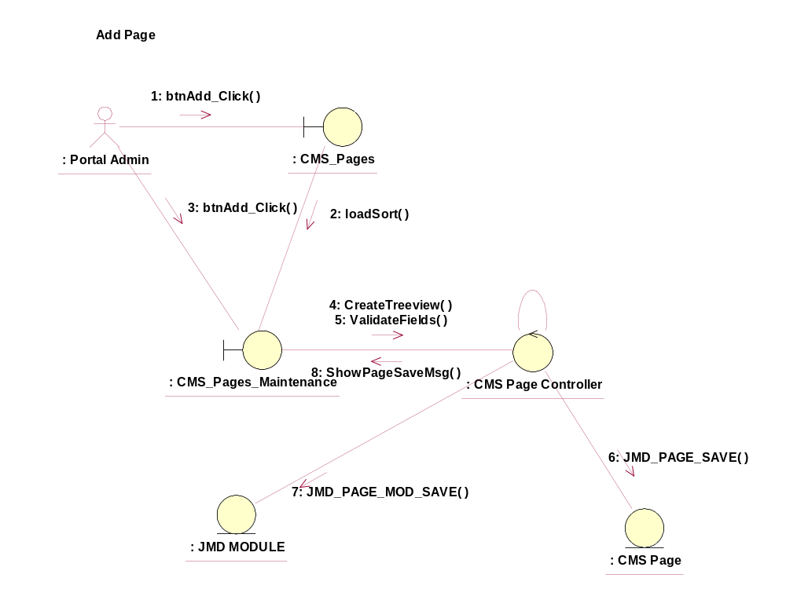

Participating Objects
: CMS_Page
This entity is the page object which will be used in JMD while creating the new pages after creating the outline.
: CMS_Page_Maintenance
This object will be used to create/delete/view/update the pages upon successful creation of the sites and outline.
: CMS_Page_Controller
This is the controller to add,modify,delete and view the page information.
: CMS_Page
This object will be storing the page information.
: JMD Module
This object will be saving the module information after creating the pages.

Class Diagrams

Class Diagram for Add Page
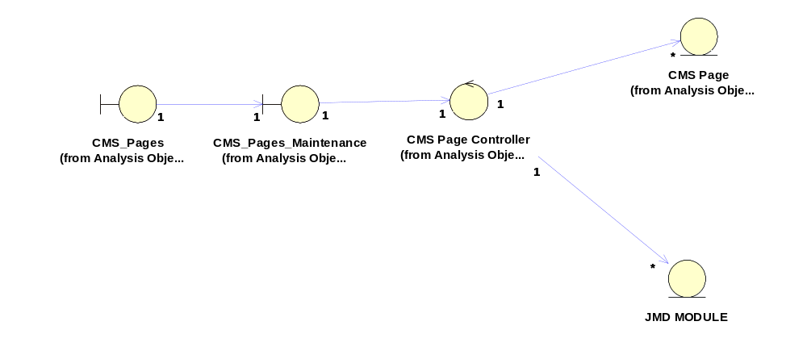

Derived Requirements
[enter the derived requirements here]

